2024 Kingswood Salver - Saturday 9th November 2024
Judging and afternoon Talk at West Monkton Village Hall,
Monkton Heathfield, Taunton, TA2 8NE
10.30 am for 11.00 am Start  Talk 2.00 pm - Close 4.00 pm | New for 2024 - Panels of 3 Mounted Prints | Awards for Best Panels &  Best Individual Prints
Closing Date – Hand in Prints at AGM Saturday 5th October 2024
The Judge and Speaker will be Gareth Martin AWPF CPAGB. Gareth is a very experienced Judge and Speaker, and a founder of Cymru Monochrome. Gareth will entertain us with his new talk “Bodies of Work and the Single Print”
This Annual Club event is for a themed panel of prints by five (or three) different photographers from the same Club. The Kingswood Salver will be awarded to the best panel of five prints, the Lanes Trophy to the best panel of three prints, and the Vivian Croucher Memorial Plate goes to the single best print overall.
Enter FIVE MOUNTED PRINTS or (new for 2024) THREE MOUNTED PRINTS at or before the AGM on Saturday 5 October 2024. The new competition for three prints is to encourage small clubs or those who haven’t entered the Kingswood Salver before.
All Entries and Winners will be displayed on the WCPF website and Facebook after the event. All Club entries from previous years can be seen on the Kingswood Salver page of the WCPF website.

Entry Fee £15 or £10 per Club payable to WCPF, bank details on form
Admittance Fee £5 CASH at the Door

Winning Panel from 2023
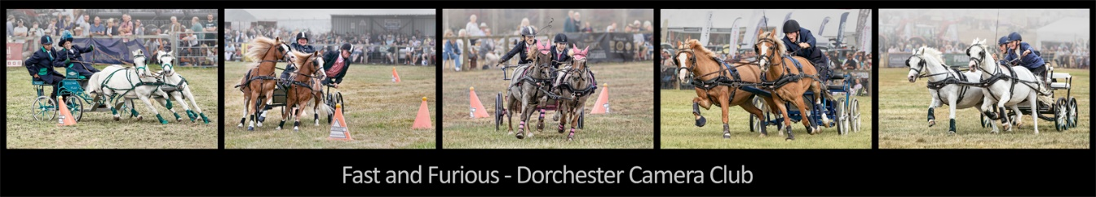
Kingswood Salver Instructions & Entry Form
Judging Saturday 9th November 2024 at West Monkton Village Hall
Monkton Heathfield, Taunton, TA2 8NE
Your Kingswood entry must be a panel of five or three 50cm x 40cm mounted prints - Colour, Mono or Both - to be judged as a panel. Prints must be from different photographers. Members may only submit a print for one club, and Clubs are only allowed to make one entry.
Label your mounted prints on the reverse with a number indicating panel order (left to right), Title and Photographer details as entered on the form below and club name.
Deliver your labelled Prints - WCPF AGM on 5th October 2024 or any WCPF Exec by 4th October.
Email kingswood.wcpf@gmail.com no later than 5th October 2024 with your completed Entry Form, digital copies of the prints, plus a digital montage of the entire panel. Include your panel title on the digital montage (for an example, see previous page).
Digital images must be in jpeg format at a maximum size of 1600 x 1200 pixels.
Name each digital image file with a prefix from 1 to 5 (or 3) in panel order, underscore, Title, underscore, Photographers Name and Distinctions (e.g., "3_Sunset over the Sea_John Smith”).
Club Name: (Club must be current WCPF Member)
Contact name:
Contact e-mail: Phone Number:
Panel Title: Number of Prints: 3 or 5
Print | Print Title | Photographer/Distinctions  (Full Name please)
1
2
3
4
5
You will be sent confirmation of receipt of your entry form
PLEASE arrange for your Panel to be collected after the judging on 9th November
Club Entry Fee £15 for Panel of Five Prints / £10 for Panel of Three Prints
Pay direct to WCPF - Sort Code 40-34-39 Account 31158139 - Ref Club Name

